**Increase the VM version from 14 to 15 on a vSphere environment**

**Prerequisites**

1. **vSphere Client Access**: Ensure you have access to the vSphere Client.
2. **Backup**: It is recommended to take a snapshot of the VM or have a backup before performing the upgrade.

**Steps to Upgrade VM Version**

**Step 1: Power Off the Virtual Machine**

1. Log in to the vSphere Client.

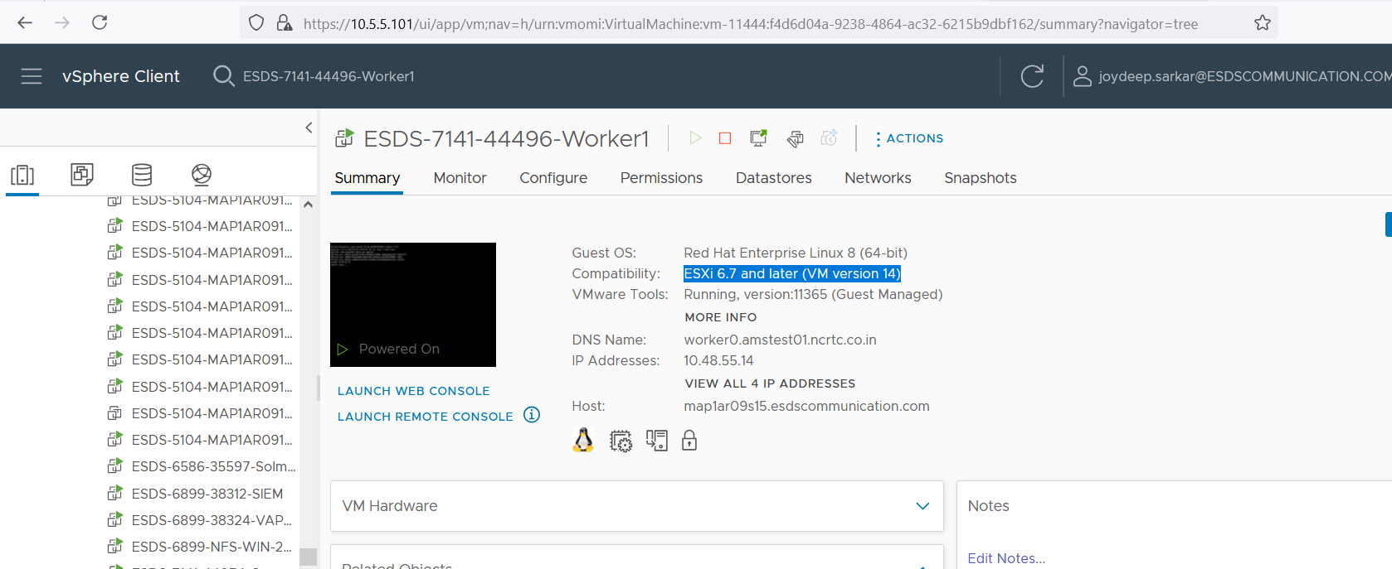

1. Locate the virtual machine you want to upgrade.
2. Right-click on the virtual machine and select Power > Power Off.

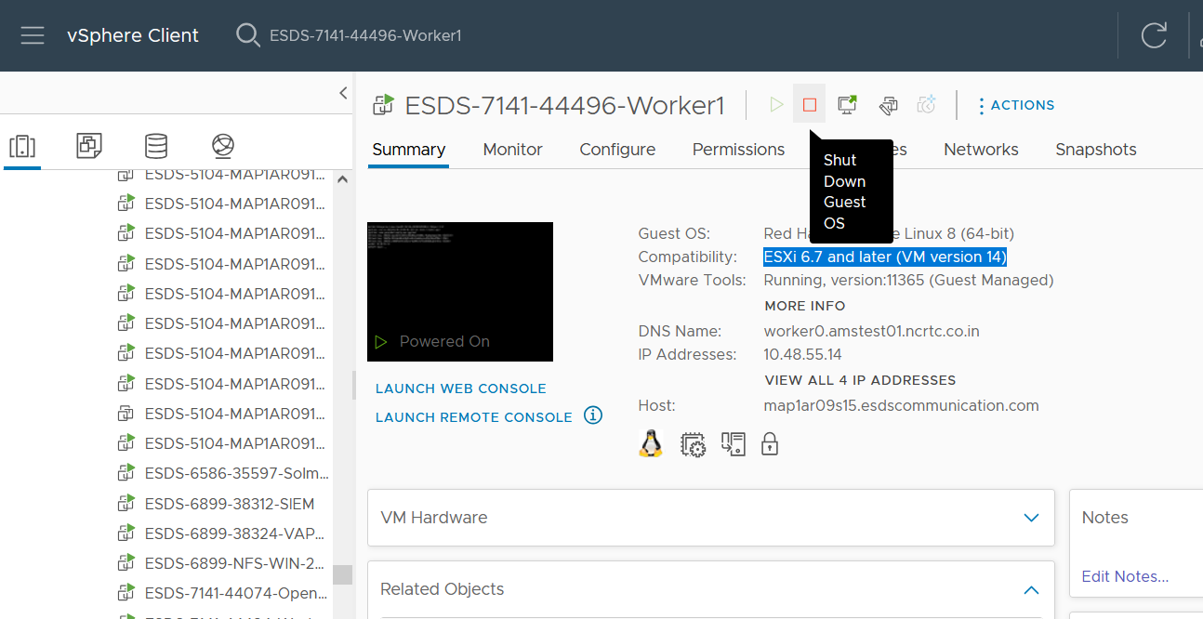

**Step 2: Upgrade VM Compatibility**

1. Right-click on the powered-off virtual machine.
2. Select Compatibility > Upgrade VM Compatibility.
3. Choose the desired compatibility version (in this case, version 15).
4. Click OK to confirm the upgrade.

**Step 3: Power On the Virtual Machine**

1. Right-click on the virtual machine.
2. Select Power > Power On.

**Step 4: Verify the Upgrade**

1. Once the VM is powered on, right-click on the VM.
2. Select Edit Settings.
3. Verify that the compatibility version has been upgraded to version 15.

